24ADI204 Data Science and Visualization · DATA-VIZ HACK-A-BIT (2026-2027)
Project Report
“The Heat is On: A Visual Timeline of Global Warming”
Team 17 · Work completed in Weeks 1 to 7 · October 2026

1. Introduction
Climate change is one of the most important environmental topics of our time, and temperature anomaly is one of the main ways it is measured. A temperature anomaly is the difference between an observed temperature and a long-term average: a positive value means warmer than the average and a negative value means cooler.
In this project we study temperature anomalies and related environmental indicators for 195 countries from 1900 to 2023. We follow the complete data science workflow taught in the course: understanding the data, cleaning it, exploring it with visualizations, engineering the features and reducing the dimensions. This report describes what we did in each week, the concepts we applied and the results we obtained.

Problem statement
Large tables of climate measurements are difficult to understand by reading the numbers alone. Our aim is to examine how temperature anomalies vary over time and across countries, to see how they relate to other indicators such as emissions, energy use and biodiversity, and to present the results in a clear visual form.

Objectives
- Understand the structure and quality of the dataset.
- Clean the dataset by handling missing values and checking for duplicates and outliers.
- Explore the data through univariate, bivariate and multivariate visualizations.
- Prepare the features through statistical analysis, scaling and encoding.
- Study the relationships between features and apply Principal Component Analysis (PCA).
- Build towards an interactive dashboard that tells the story of the data.

Tools used
- Python in Google Colab for all the analysis.
- Pandas and NumPy for loading, cleaning and calculating.
- Matplotlib and Seaborn for the visualizations.
- Scikit-learn for scaling and PCA, and SciPy for the Z-score.
- GitHub for version control, with one folder for each week.

Weekly workflow
Week | Activity | Main output
1 | Dataset selection and project setup | Project abstract, introduction presentation, raw dataset
2 | Know your data: data quality assessment | Data_Quality_Assessment.ipynb, Cleaned_Dataset.ipynb
3 | Cleaning sprint: missing values and outlier detection | Cleaning_sprint.ipynb, cleaned dataset
4 | Exploratory data analysis | EDA_plots.ipynb with 30 visualizations
5 | Mid-review | Mid-review presentation
6 | Feature engineering: scaling and encoding | Feature_Engineering.ipynb, standard-scaled dataset
7 | Feature selection and PCA | PCA.ipynb

2. Dataset
We selected the “Global Warming Dataset: 195 Countries (1900-2023)” from Kaggle. It is a large structured dataset that covers many countries and more than a century of records, and it contains missing values, which makes it suitable for demonstrating the full workflow.
- Size: 100,000 records and 26 columns.
- Coverage: 195 country labels (Country_1 to Country_195) and every year from 1900 to 2023.
- Main variable: Temperature_Anomaly.
- Column types: one categorical column (Country), two integer columns (Year and Extreme_Weather_Events) and 23 decimal columns.
- Indicators: emissions (CO2_Emissions, Methane_Emissions, Per_Capita_Emissions), climate (Average_Temperature, Sea_Level_Rise, Arctic_Ice_Extent, Average_Rainfall, Ocean_Acidification), energy (Renewable_Energy_Usage, Fossil_Fuel_Usage, Energy_Consumption_Per_Capita), environment (Forest_Area, Deforestation_Rate, Biodiversity_Index) and socio-economic factors (Population, GDP, Urbanization, Industrial_Activity, Policy_Score).
- Records per group: each country has between 457 and 557 records, and each year has between 732 and 881 records, so the data is well balanced.
We keep three versions of the dataset in the repository, one for each stage of the work:
File | Rows | Columns | Missing cells | Duplicate rows
Week 1: raw dataset | 100,000 | 26 | 12,000 | 0
Week 3: cleaned dataset | 100,000 | 26 | 0 | 0
Week 6: standard-scaled dataset | 100,000 | 26 | 0 | 0

3. Week 2: Know your data

Concept
Before any analysis, the quality of the data has to be checked. A data quality assessment answers basic questions: how big is the dataset, what type of value does each column hold, are any values missing, are any rows repeated, and are the values within a sensible range. The answers decide what cleaning is needed.

What we did
We loaded the CSV file into a Pandas DataFrame and inspected its shape, column names and data types. We then built a missing-value report that gives the count and percentage of missing values for each column, and we checked for duplicate rows.
Code
df = pd.read_csv(csv_path)
print("Number of rows:", df.shape[0])
print("Number of columns:", df.shape[1])

missing_report = pd.DataFrame({
"Data_Type": df.dtypes.astype(str),
"Missing_Count": df.isnull().sum(),
"Missing_Percentage": (df.isnull().sum() / len(df) * 100).round(2)})
display(missing_report[missing_report["Missing_Count"] > 0])

duplicate_count = df.duplicated().sum()
Output
Dataset loaded successfully!
Number of rows: 100000
Number of columns: 26

Dataset shape: (100000, 26)
Total missing cells: 12000

Columns containing missing values:
Data_Type Missing_Count Missing_Percentage
Biodiversity_Index float64 2000 2.0
Ocean_Acidification float64 2000 2.0
Fossil_Fuel_Usage float64 2000 2.0
Energy_Consumption_Per_Capita float64 2000 2.0
Policy_Score float64 2000 2.0
Average_Temperature float64 2000 2.0

Total duplicate rows: 0
We also looked at how the records are organised by country and year. The dataset holds several records for the same country and year, each with its own set of measurements, so we treated every record as a separate observation.
Output
Unique countries: 195
Minimum year: 1900
Maximum year: 2023

Total records: 100000
Unique Country-Year combinations: 23797
Finally we validated the value ranges. We checked 16 columns that must not be negative, 8 percentage columns that must stay between 0 and 100, the range of years and the format of the country labels.
Output
Negative values check:
Population: 0
CO2_Emissions: 0
Forest_Area: 0
GDP: 0
Renewable_Energy_Usage: 0
Methane_Emissions: 0
Average_Rainfall: 0
Solar_Energy_Potential: 0
Waste_Management: 0
Per_Capita_Emissions: 0
Industrial_Activity: 0
Air_Pollution_Index: 0
Biodiversity_Index: 0
Fossil_Fuel_Usage: 0
Energy_Consumption_Per_Capita: 0
Policy_Score: 0

Minimum Year: 1900
Maximum Year: 2023
Number of unique years: 124
Missing years:
[]

Missing Country values: 0
Number of unique countries: 195
Leading/trailing spaces: 0

Result
- The dataset has 100,000 rows and 26 columns.
- 12,000 cells are missing: exactly 2,000 (2%) in each of six numeric columns.
- There are no duplicate rows.
- All values are inside their valid ranges, and every year from 1900 to 2023 is present.
This told us that the main cleaning task for Week 3 was to handle the missing values.

4. Week 3: Cleaning sprint

Concepts
Imputation means filling a missing value with an estimate, so that the rest of the row is not lost. The two common choices for numeric data are the mean and the median. We chose the median because it is the middle value of the column and is not pulled up or down by extreme values, so it is the safer choice. Since only 2% of each column was missing, imputation keeps all 100,000 records without changing the columns noticeably.
An outlier is a value that lies far from the rest of the data. We used two standard methods to detect outliers:
- IQR method. IQR = Q3 − Q1, where Q1 and Q3 are the 25th and 75th percentiles. A value is an outlier if it is below Q1 − 1.5 × IQR or above Q3 + 1.5 × IQR.
- Z-score method. Z = (value − mean) ÷ standard deviation. A value is an outlier if its Z-score is above 3 or below −3.
A boxplot shows the same idea as a picture: the box runs from Q1 to Q3, the line inside is the median, and any outliers appear as separate points beyond the whiskers.

What we did
We kept the raw data unchanged in df_raw and did all the cleaning on a copy. We first recorded the baseline, then applied median imputation to the six columns with missing values.
Output
RAW DATASET BASELINE
----------------------------------------
Rows: 100000
Columns: 26
Missing cells: 12000
Exact duplicate rows: 0
Code
imputation_medians = df[missing_cols].median()
df[missing_cols] = df[missing_cols].fillna(imputation_medians)
Output
Total missing cells before: 12000
Total missing cells after: 0

Median values used:
Median_Used
Biodiversity_Index 50.097524
Ocean_Acidification 8.001393
Fossil_Fuel_Usage 50.012808
Energy_Consumption_Per_Capita 2546.616430
Policy_Score 49.957149
Average_Temperature 15.032100
We then applied the IQR method and the Z-score method to every numeric column and compared the two results.
Code
q1 = df[col].quantile(0.25)
q3 = df[col].quantile(0.75)
iqr = q3 - q1
lower_bound = q1 - 1.5 * iqr
upper_bound = q3 + 1.5 * iqr
outlier_count = ((df[col] < lower_bound) | (df[col] > upper_bound)).sum()

z_scores = (values - values.mean()) / values.std(ddof=0)
mask = z_scores.abs() > 3
Output
Numeric columns checked: 25

Total potential outliers detected:
IQR method: 0
Z-score method: 0.0
For example, for CO2_Emissions Q1 is about 250 million and Q3 about 751 million, so the IQR is about 500 million and the upper limit is about 1,501 million. The largest value is about 1,000 million, which is inside the limit. In every column the Z-scores stay between about −1.73 and +1.73, well inside the threshold of 3. We also drew boxplots for six key columns as a visual check.
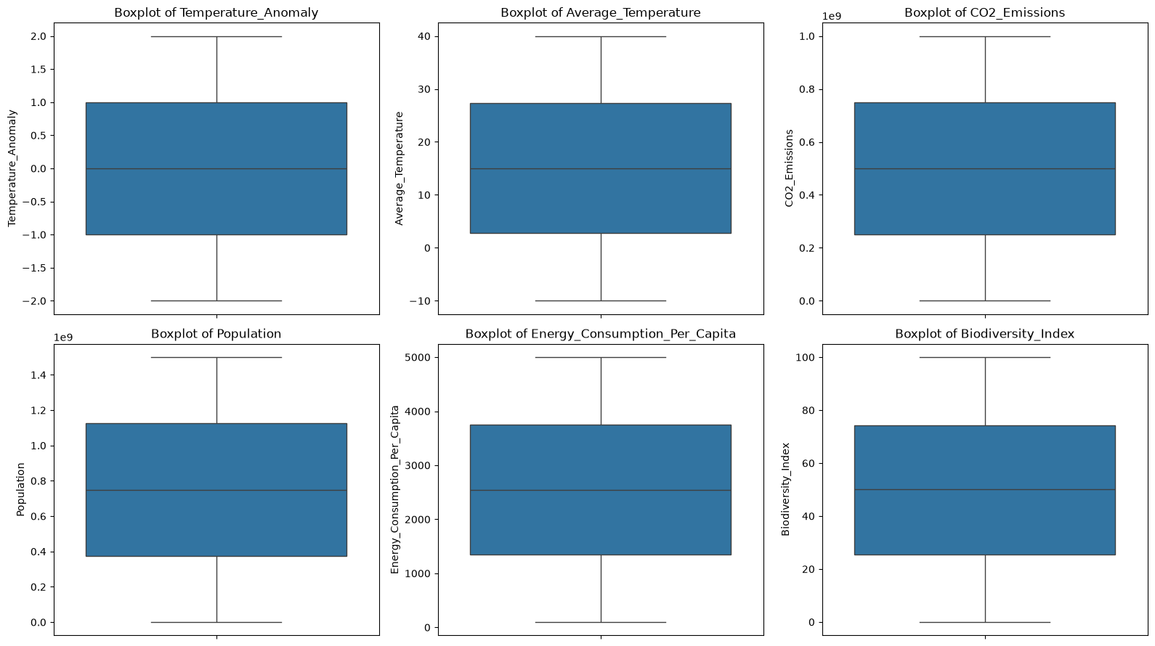
Figure 1. Boxplots of six columns after cleaning. No points fall outside the whiskers, which agrees with the IQR and Z-score results.
We checked the value constraints again on the cleaned data. Negative values of Average_Temperature were kept, because temperatures below zero are valid in degrees Celsius (the column runs from −10 to 40).
Output
Year before 1900: 0
Year after 2023: 0
Negative Biodiversity_Index: 0
Biodiversity_Index above 100: 0
Negative CO2_Emissions: 0
Negative Population: 0
Negative GDP: 0

Result
The table below compares the dataset before and after cleaning. We also saved a cleaning log that records each decision, and we verified the exported file by reloading it.
Metric | Before cleaning | After cleaning
Number of rows | 100,000 | 100,000
Number of columns | 26 | 26
Total missing cells | 12,000 | 0
Exact duplicate rows | 0 | 0
Country labels with whitespace | 0 | 0

Output
EXPORT VERIFICATION
Original working DataFrame shape: (100000, 26)
Reloaded CSV shape: (100000, 26)
Missing cells in exported CSV: 0
Exact duplicate rows in exported CSV: 0

Export verification passed.
After the cleaning sprint the dataset is complete: 100,000 records, no missing values, no duplicate rows and no outliers. No records had to be removed.

5. Week 4: Exploratory data analysis

Concepts
Exploratory Data Analysis (EDA) means studying the data through statistics and visualizations in order to understand its patterns before any modelling. We organised our EDA in three levels:
- Univariate analysis looks at one variable at a time and shows its distribution. We used histograms, KDE plots, boxplots, violin plots and an ECDF.
- Bivariate analysis looks at two variables together and shows their relationship. We used scatter plots, a regression plot, a hexbin plot and a joint plot.
- Multivariate analysis looks at several variables at once. We used correlation heatmaps, a pair plot and a parallel-coordinates plot.
Correlation (Pearson’s r) measures the linear relationship between two variables on a scale from −1 to +1. A value near +1 or −1 means a strong relationship, and a value near 0 means the two variables vary independently.

What we did
We loaded the cleaned dataset and created 30 visualizations with Matplotlib and Seaborn, each of a different chart type, so that the data could be seen from many angles. For the plots that draw individual points we used random samples of the data, which keeps the plots readable. The figures below are the main ones, and all 30 are given in the appendix.
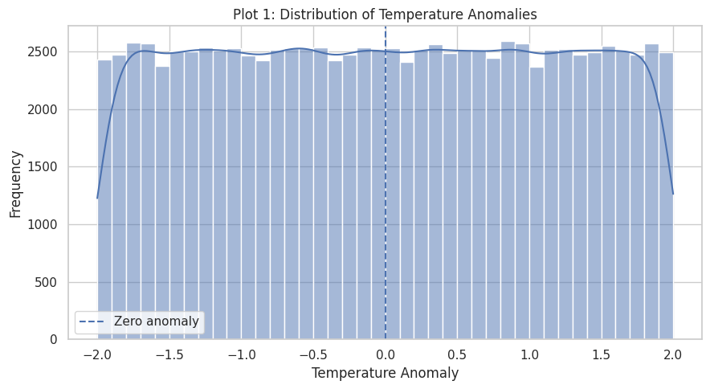
Figure 2. Plot 1. Distribution of temperature anomalies. The values range from −2 to +2 and are evenly distributed across the range.
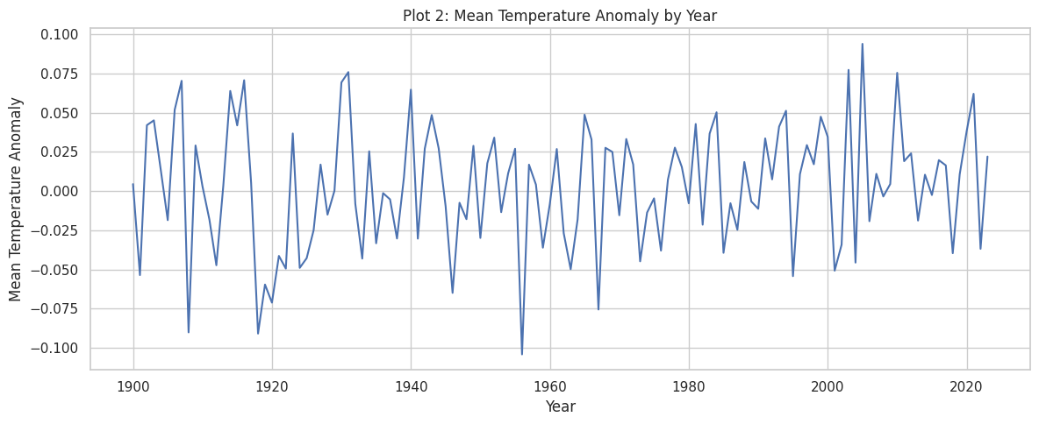
Figure 3. Plot 2. Mean temperature anomaly by year, 1900 to 2023. The yearly mean stays close to zero, within about ±0.1.
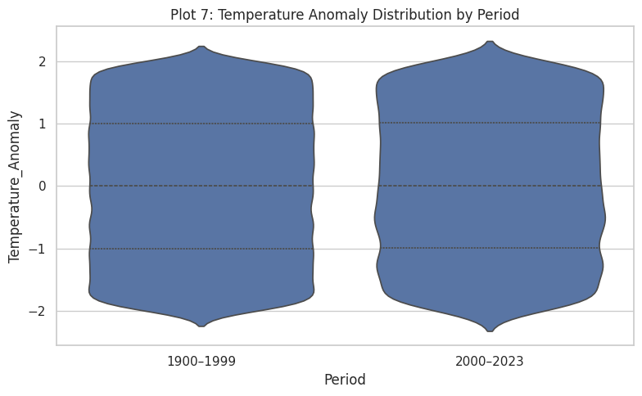
Figure 4. Plot 7. Temperature anomaly for 1900–1999 and 2000–2023. Both periods have the same median and the same spread.
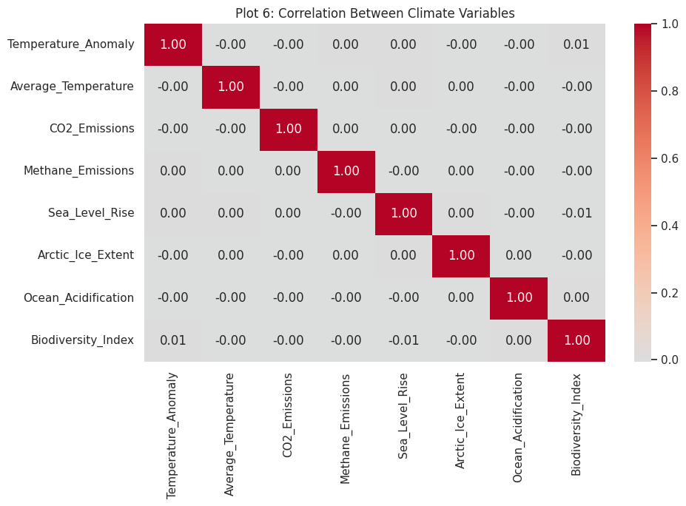
Figure 5. Plot 6. Correlation between eight climate variables. The correlations between different variables are close to zero.
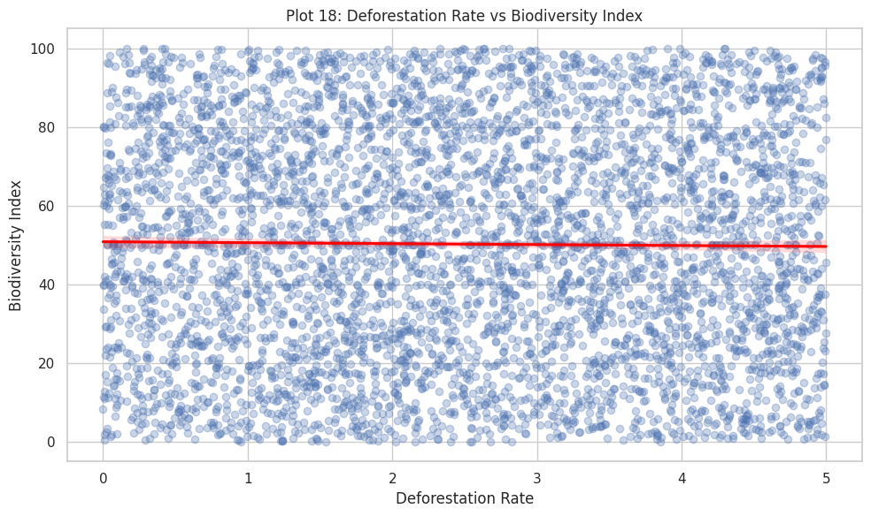
Figure 6. Plot 18. Deforestation rate against biodiversity index with a fitted regression line.
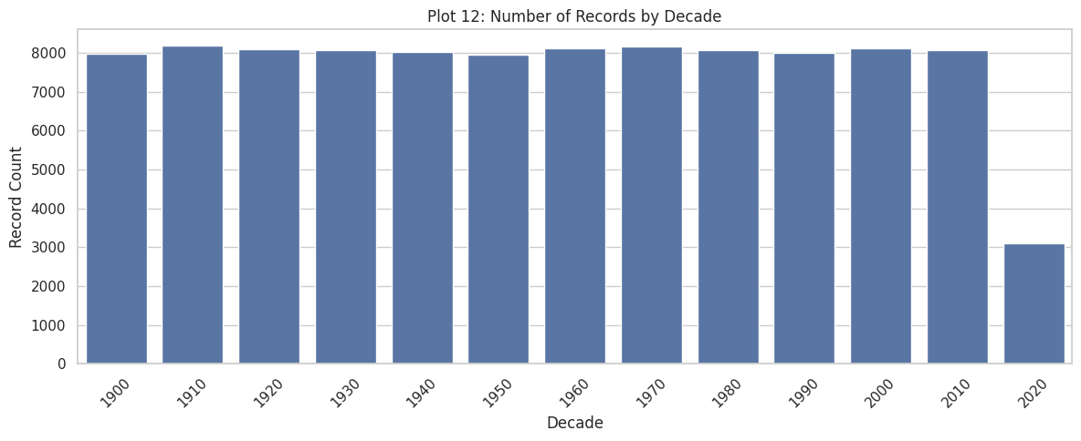
Figure 7. Plot 12. Number of records in each decade. The decades are evenly represented; the 2020s cover four years (2020 to 2023).

Result
- Distribution. Temperature anomalies range from −2 to +2 and are evenly distributed, with a mean very close to zero. The other indicators are also evenly distributed across their ranges.
- Time. The yearly mean anomaly stays within about ±0.1 from 1900 to 2023, and the two periods we compared have the same distribution.
- Countries. The mean anomaly of the highest country is about 0.2, so the countries are close to each other.
- Relationships. The correlations between the variables are close to zero, which means the indicators in this dataset vary independently of each other.
- Balance. The records are evenly spread across decades and countries, so the comparisons are fair.
These results come from exploratory analysis of this dataset, and they guided the next two weeks: because the variables are on very different scales we scaled them in Week 6, and because they are weakly correlated we examined this further with a full correlation matrix and PCA in Week 7.

The 30 visualizations
No. | Plot type | What it shows
1 | Histogram with KDE | Temperature_Anomaly
2 | Line chart | Mean anomaly by year
3 | Horizontal bar | Top 10 country labels by mean anomaly
4 | Boxplot | Average_Temperature
5 | Scatter | CO2_Emissions vs anomaly
6 | Correlation heatmap | 8 climate variables
7 | Violin | Anomaly, 1900–1999 vs 2000–2023
8 | ECDF | Temperature_Anomaly
9 | KDE | Renewable_Energy_Usage
10 | Hexbin | Population vs GDP
11 | Pair plot | 4 variables, 1,500-row sample
12 | Count plot | Records by decade
13 | Bubble chart | GDP vs CO2, size = renewable usage
14 | Stacked area | 4 indicator means by year
15 | Lollipop | Mean renewable vs fossil fuel usage
16 | Strip plot | Anomaly, 1,200-row sample
17 | Joint plot | Average_Temperature vs anomaly
18 | Regression plot | Deforestation vs biodiversity
19 | Residual plot | CO2 vs anomaly, LOWESS line
20 | Pie chart | Mean renewable vs fossil fuel usage
21 | Radar chart | 5 indicator means
22 | 2-D density | CO2 vs methane emissions
23 | Step chart | Yearly mean extreme weather events
24 | Rug plot | Sea_Level_Rise
25 | Error-bar line | Yearly mean anomaly ± standard error
26 | Grouped bar | Energy usage by anomaly category
27 | Clustered heatmap | 10-variable correlation
28 | Parallel coordinates | 5 indicators, 300-row sample
29 | Boxen plot | Industrial_Activity
30 | Word cloud | Country labels by row count

6. Week 6: Feature engineering

Concepts
Skewness measures whether a distribution leans to one side. A value near 0 means the distribution is symmetric; a clearly positive or negative value means a long tail on one side, which is usually corrected with a log or power transformation.
Kurtosis describes the tails of a distribution compared with a normal distribution, for which Pandas reports 0. A negative value means lighter tails and a flatter shape.
Feature scaling puts all numeric columns on a comparable scale. This is needed because our columns differ hugely: GDP is in trillions, while the temperature anomaly lies between −2 and 2. Without scaling, the large columns would dominate methods such as PCA.
- StandardScaler: (value − mean) ÷ standard deviation. The result has mean 0 and standard deviation 1.
- MinMaxScaler: (value − minimum) ÷ (maximum − minimum). The result lies between 0 and 1.
Encoding turns categories into numbers. We used one-hot encoding for Country, which creates one 0/1 column per country. We preferred it to label encoding because countries have no natural order, and label encoding would suggest one.

What we did
We first calculated the descriptive statistics of the 24 numeric features (all numeric columns except Year), including skewness and kurtosis.
Feature | Min | Max | Mean | Skewness | Kurtosis
Temperature_Anomaly | -2.000 | 2.000 | 0.003 | -0.001 | -1.200
CO2_Emissions | 1.02e+05 | 1.00e+09 | 5.01e+08 | -0.002 | -1.199
Population | 1.01e+06 | 1.50e+09 | 7.50e+08 | 0.001 | -1.200
Forest_Area | 0.000 | 100.000 | 50.012 | -0.001 | -1.197
GDP | 1.52e+08 | 1.00e+13 | 5.00e+12 | 0.006 | -1.194
Renewable_Energy_Usage | 0.005 | 99.999 | 50.116 | -0.000 | -1.197
Methane_Emissions | 1.13e+03 | 1.00e+07 | 5.00e+06 | -0.000 | -1.203
Sea_Level_Rise | -5.000 | 49.998 | 22.568 | -0.010 | -1.205
Arctic_Ice_Extent | 1.000 | 15.000 | 8.004 | 0.004 | -1.198
Urbanization | 0.000 | 100.000 | 49.919 | 0.004 | -1.197
Deforestation_Rate | 0.000 | 5.000 | 2.494 | 0.009 | -1.198
Extreme_Weather_Events | 0 | 49 | 24.520 | -0.004 | -1.201
Average_Rainfall | 500.015 | 4999.821 | 2750.708 | -0.000 | -1.194
Solar_Energy_Potential | 500.021 | 2499.981 | 1496.453 | 0.005 | -1.197
Waste_Management | 0.000 | 100.000 | 50.010 | 0.002 | -1.198
Per_Capita_Emissions | 0.000 | 20.000 | 9.970 | 0.010 | -1.194
Industrial_Activity | 0.003 | 99.999 | 50.104 | -0.003 | -1.201
Air_Pollution_Index | 0.001 | 299.993 | 149.628 | 0.005 | -1.198
Biodiversity_Index * | 0.001 | 100.000 | 49.983 | -0.002 | -1.163
Ocean_Acidification * | 7.500 | 8.500 | 8.000 | -0.003 | -1.161
Fossil_Fuel_Usage * | 0.001 | 100.000 | 49.998 | 0.002 | -1.166
Energy_Consumption_Per_Capita * | 100.031 | 4999.981 | 2547.965 | 0.000 | -1.165
Policy_Score * | 0.003 | 100.000 | 49.987 | -0.003 | -1.161
Average_Temperature * | -10.000 | 39.999 | 15.033 | -0.002 | -1.163

* Columns that had 2% of their values filled with the median in Week 3.
The skewness of every feature is very close to 0, so the distributions are symmetric and no skewness correction was needed. The kurtosis values are negative, which shows that the distributions are flatter than a normal distribution.
We then applied both scalers to the numeric features and one-hot encoded the Country column. Year was left unscaled because it is a time label. The original cleaned data was preserved, and each transformed dataset was saved separately.
Code
scaler = StandardScaler()
df_scaled[numeric_features] = scaler.fit_transform(df[numeric_features])

minmax_scaler = MinMaxScaler()
df_minmax[numeric_features] = minmax_scaler.fit_transform(df[numeric_features])

df_encoded = pd.get_dummies(df_scaled, columns=["Country"], dtype=int)
Output
Scaling completed!
Original dataset shape: (100000, 26)
Transformed dataset shape: (100000, 26)

Original columns: 26
Columns after encoding: 220

Week 6 files saved successfully:
- Week6_StandardScaled_Dataset.csv
- Week6_MinMaxScaled_Dataset.csv
- Week6_Encoded_Dataset.csv
- Week6_Descriptive_Statistics.csv
To verify the scaling we compared the mean and standard deviation of each feature before and after. We also plotted four features before and after standard scaling.
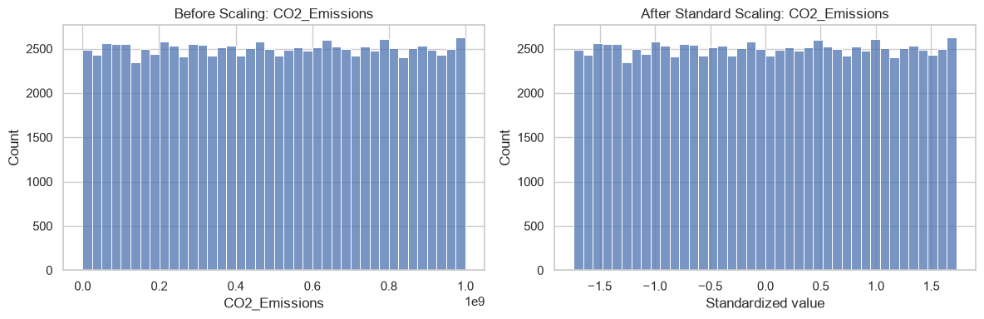
Figure 8. Before and after standard scaling: CO2_Emissions.
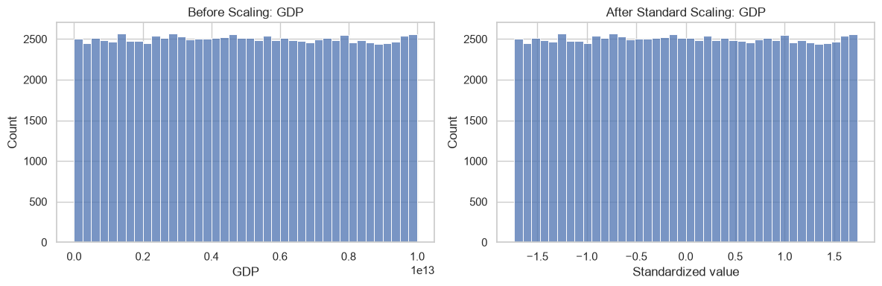
Figure 9. Before and after standard scaling: GDP.
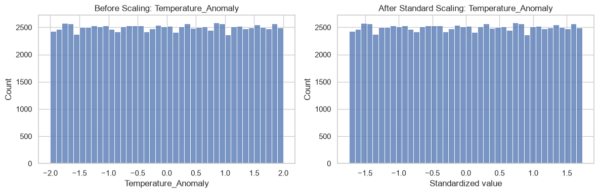
Figure 10. Before and after standard scaling: Temperature_Anomaly.
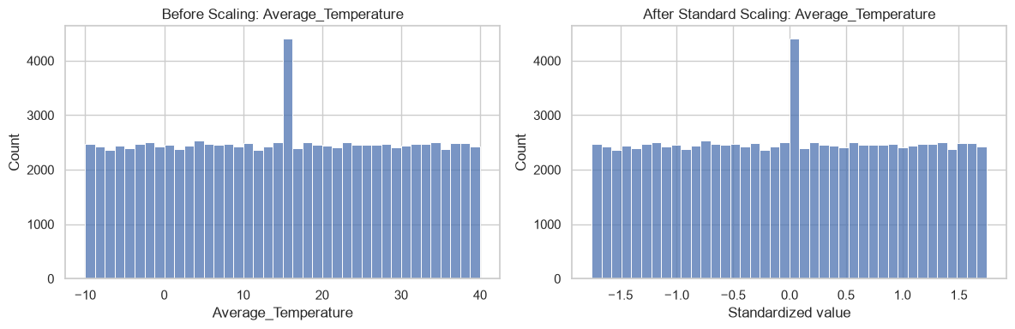
Figure 11. Before and after standard scaling: Average_Temperature. The taller bar in the centre comes from the median imputation done in Week 3.

Result
- After StandardScaler every numeric feature has mean 0 and standard deviation 1.
- After MinMaxScaler every numeric feature lies between 0 and 1.
- The before and after histograms show that scaling changes the scale of a feature but keeps the shape of its distribution.
- After one-hot encoding the dataset has 220 columns: the 25 other columns plus 195 country columns.
The standard-scaled dataset is the input for the dimensionality reduction in Week 7.

7. Week 7: Feature selection and PCA

Concepts
Multicollinearity occurs when two features are very highly correlated, so that they carry almost the same information. In feature selection, one feature of such a pair can be removed. We used an absolute correlation of 0.90 as the threshold.
Principal Component Analysis (PCA) is a dimensionality reduction technique. It combines the original features into new variables called principal components. The components are uncorrelated with each other and are ordered by the amount of variance they capture: the first component captures the most, the second captures the most of what remains, and so on.
The explained variance ratio of a component is the share of the total variance it captures. By adding these shares up (the cumulative explained variance) we can choose the smallest number of components that keeps a required amount of the information. We set this target at 90%. PCA must be applied to scaled data, which is why Week 6 came first.

What we did
We loaded the standard-scaled dataset and selected the 24 numeric features, leaving out Year and Country. We built the correlation matrix and searched for feature pairs with an absolute correlation of 0.90 or more.
Output
Dataset shape: (100000, 26)
Missing values: 0
Duplicate rows: 0

Number of numerical features: 25
Number of candidate features: 24

Highly correlated feature pairs (|r| >= 0.90):
Empty DataFrame
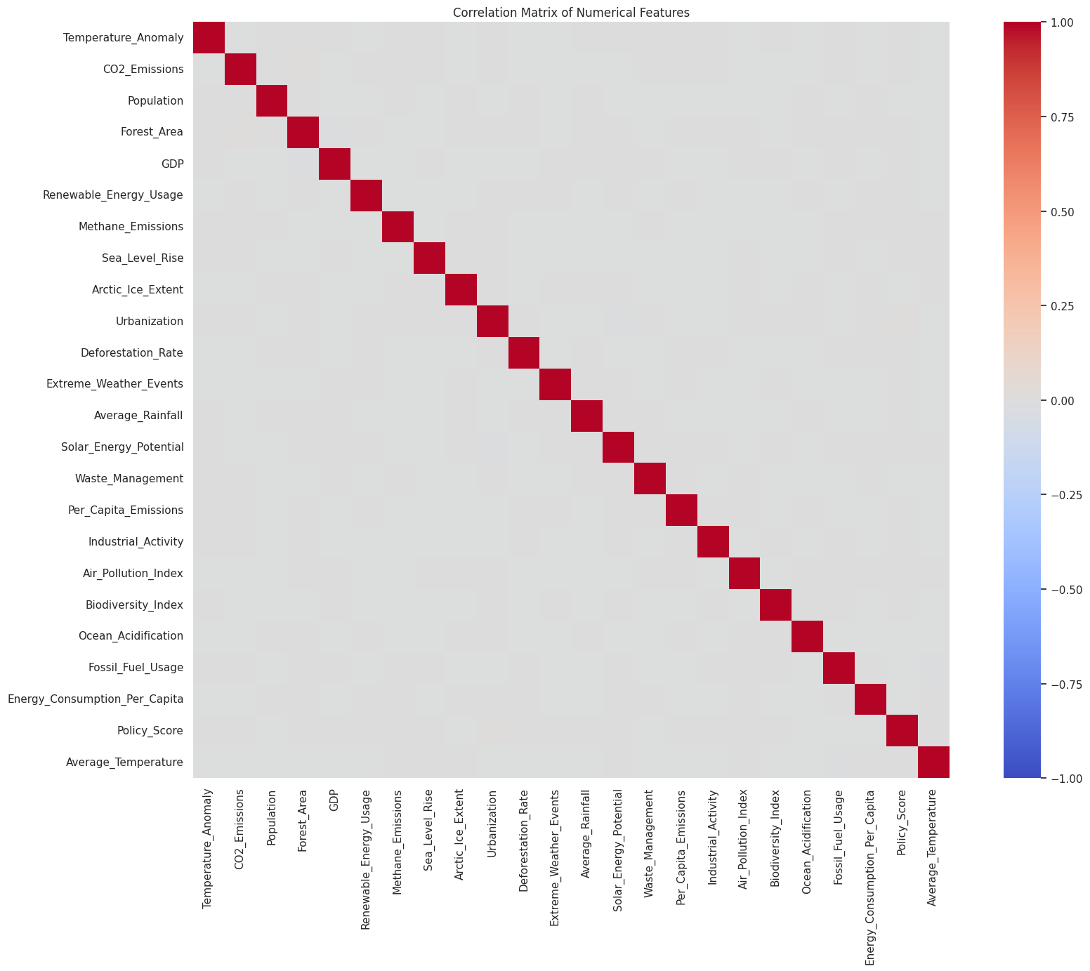
Figure 12. Correlation matrix of the 24 numeric features.
No pair of features reached the threshold, so there is no multicollinearity and all 24 features were kept. We then fitted PCA on the 24 features, calculated the cumulative explained variance and kept the number of components needed for at least 90%.
Code
pca = PCA()
X_pca = pca.fit_transform(X)
cumulative_variance = np.cumsum(pca.explained_variance_ratio_)
components_90 = np.argmax(cumulative_variance >= 0.90) + 1

pca_reduced = PCA(n_components=components_90)
X_reduced = pca_reduced.fit_transform(X)
Output
Original number of features: 24
Number of principal components: 24

Components needed for at least 90% variance: 22
Cumulative variance retained: 91.88 %

Original feature count: 24
Reduced feature count: 22
Explained variance retained: 91.88 %

Variance explained by PC1 and PC2: 8.57 %
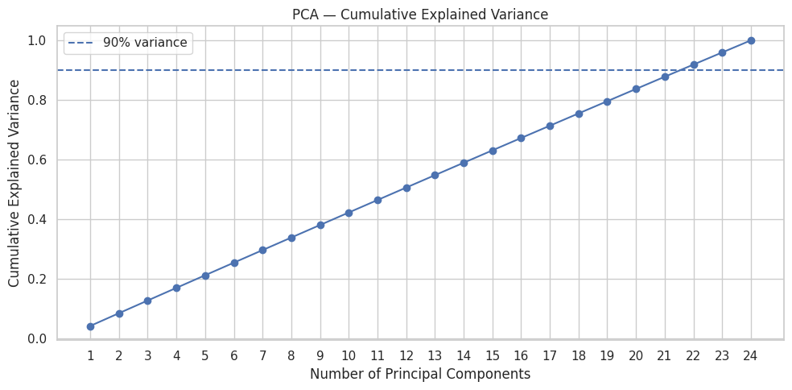
Figure 13. Cumulative explained variance. The 90% line is crossed at 22 components.
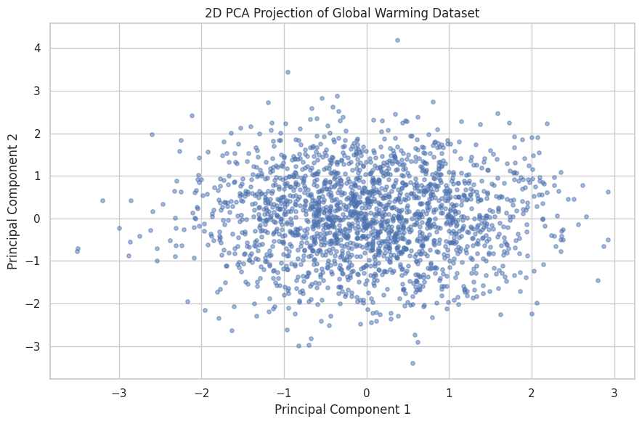
Figure 14. The first two principal components for a random sample of 2,000 records.

Result
- No feature pair has a correlation of 0.90 or more, so no feature was removed in feature selection.
- 22 principal components retain 91.88% of the total variance.
- The cumulative variance increases steadily, by about 4% for each component, because the features are weakly correlated and each one contributes its own information.
- The first two components together explain 8.57% of the variance, and the 2D projection shows the records as a single group.
The PCA-reduced dataset and the explained variance of each component were saved for later use.

8. Summary of results
The table below brings together the main results of Weeks 1 to 7.
Stage | Result
Dataset | 100,000 records, 26 columns, 195 countries, 1900 to 2023
Missing values | 12,000 cells (2% in each of six columns), filled with the column median
Duplicate rows | 0
Outliers (IQR and Z-score) | 0 in every numeric column
Cleaned dataset | 100,000 records, 0 missing values, no records removed
EDA | 30 visualizations covering univariate, bivariate and multivariate analysis
Skewness and kurtosis | Skewness about 0 and kurtosis about −1.2 for every feature
Scaling | StandardScaler (mean 0, standard deviation 1) and MinMaxScaler (0 to 1)
Encoding | One-hot encoding of Country: 26 columns became 220
Feature selection | No feature pair with correlation of 0.90 or more
PCA | 22 components retain 91.88% of the variance

Through these seven weeks we applied each stage of the data science workflow to a large dataset: we assessed its quality, cleaned it with a justified imputation method, confirmed the absence of outliers with two independent methods, explored it with a wide range of visualizations, prepared the features with scaling and encoding, and examined the feature relationships with a correlation matrix and PCA.
The next stage of the project is the interactive dashboard, where these results and visualizations will be brought together as a data story.

Appendix: all 30 EDA visualizations
These are the 30 visualizations produced in EDA_plots.ipynb, in notebook order.
Plot 1. Histogram with KDE: Temperature_Anomaly | Plot 2. Line chart: Mean anomaly by year
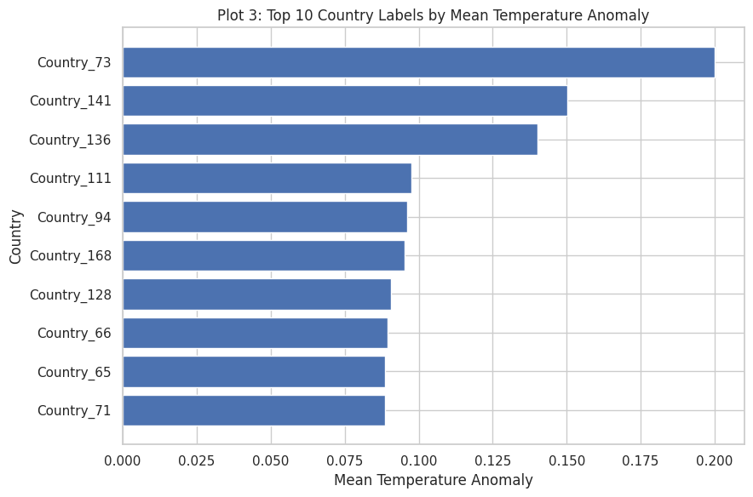  Plot 3. Horizontal bar: Top 10 country labels by mean anomaly | 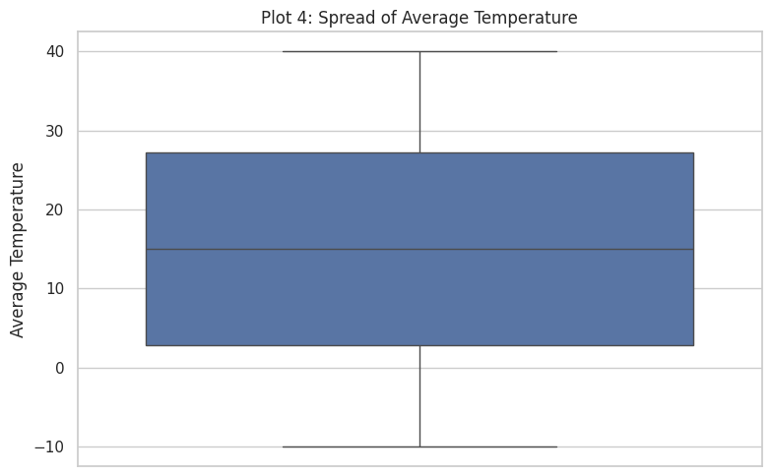  Plot 4. Boxplot: Average_Temperature
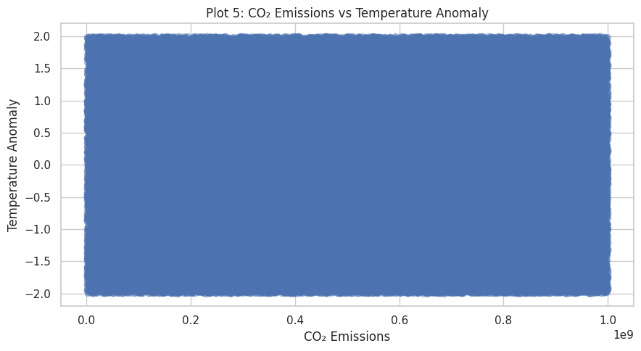  Plot 5. Scatter: CO2_Emissions vs anomaly | Plot 6. Correlation heatmap: 8 climate variables
Plot 7. Violin: Anomaly, 1900–1999 vs 2000–2023 | 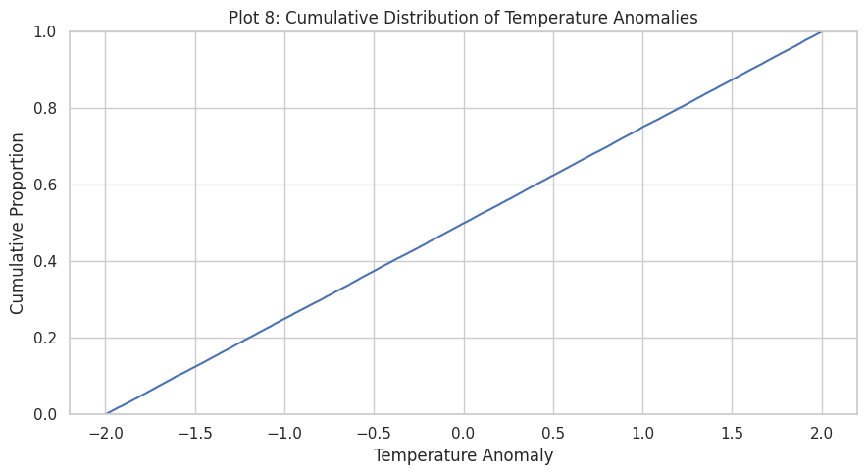  Plot 8. ECDF: Temperature_Anomaly
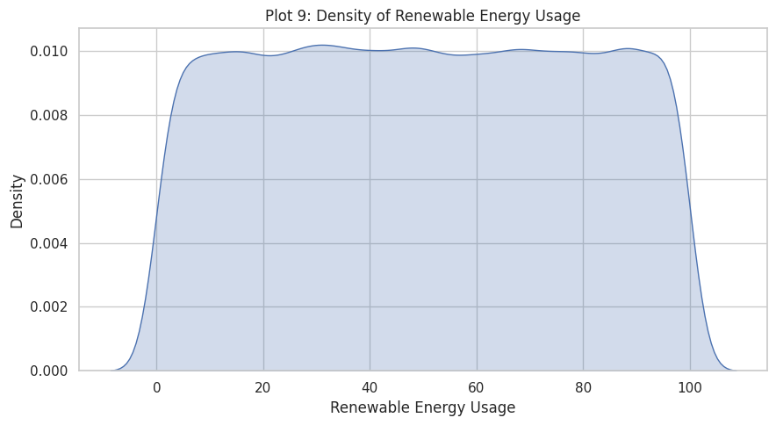  Plot 9. KDE: Renewable_Energy_Usage | 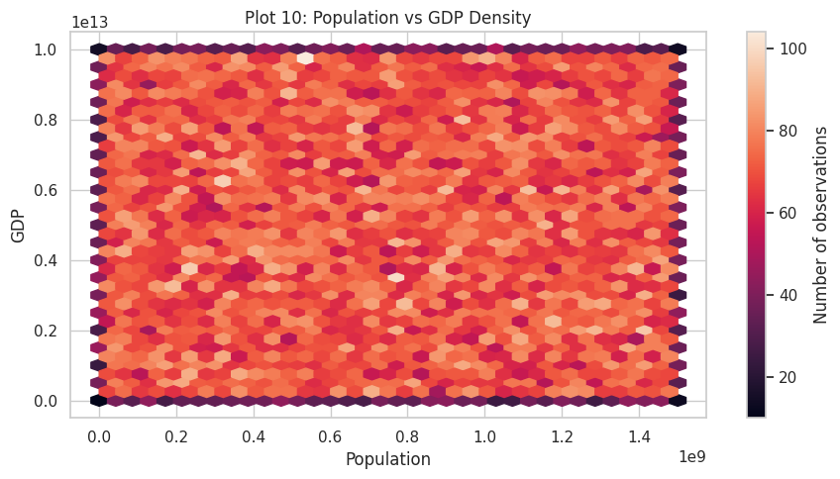  Plot 10. Hexbin: Population vs GDP
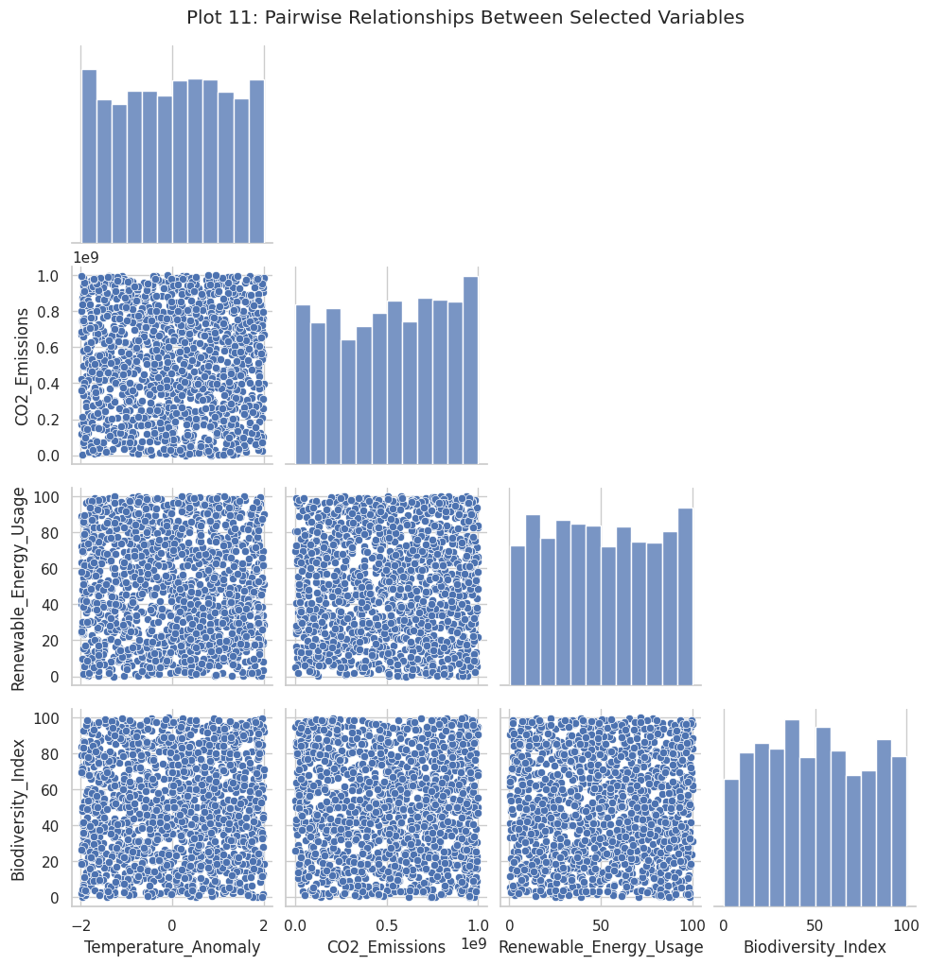  Plot 11. Pair plot: 4 variables, 1,500-row sample | Plot 12. Count plot: Records by decade
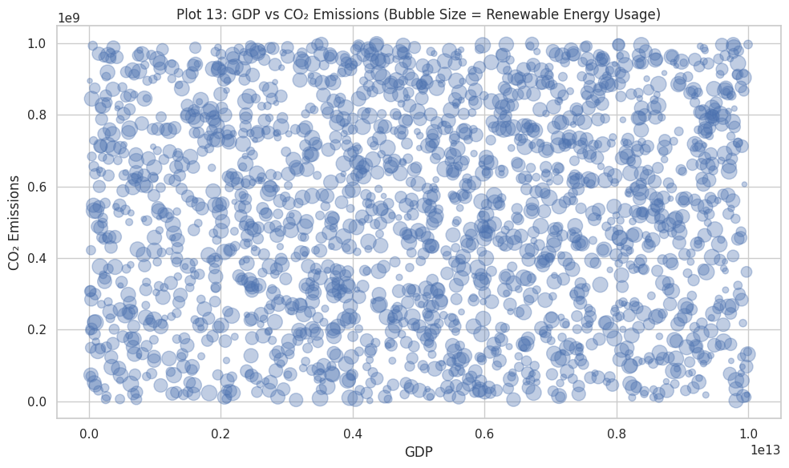  Plot 13. Bubble chart: GDP vs CO2, size = renewable usage | 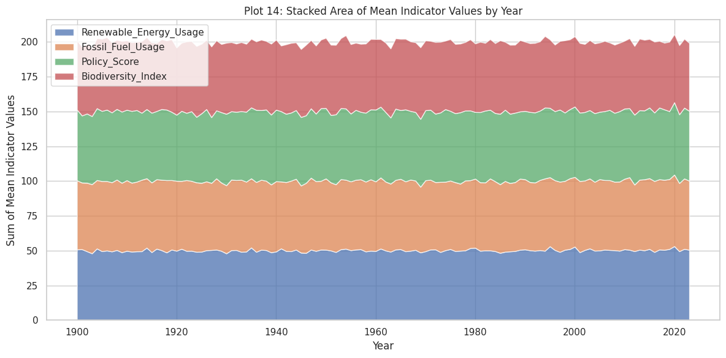  Plot 14. Stacked area: 4 indicator means by year
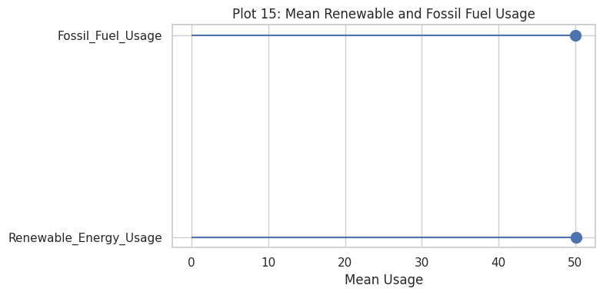  Plot 15. Lollipop: Mean renewable vs fossil fuel usage | 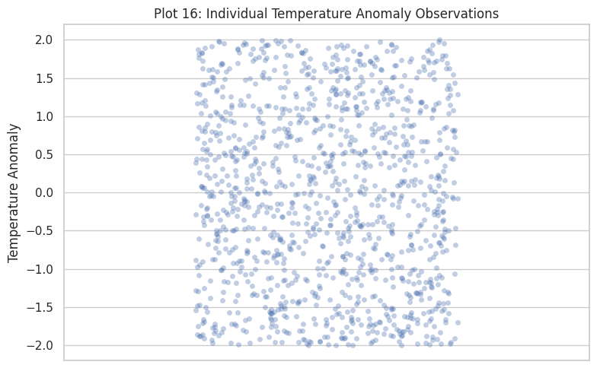  Plot 16. Strip plot: Anomaly, 1,200-row sample
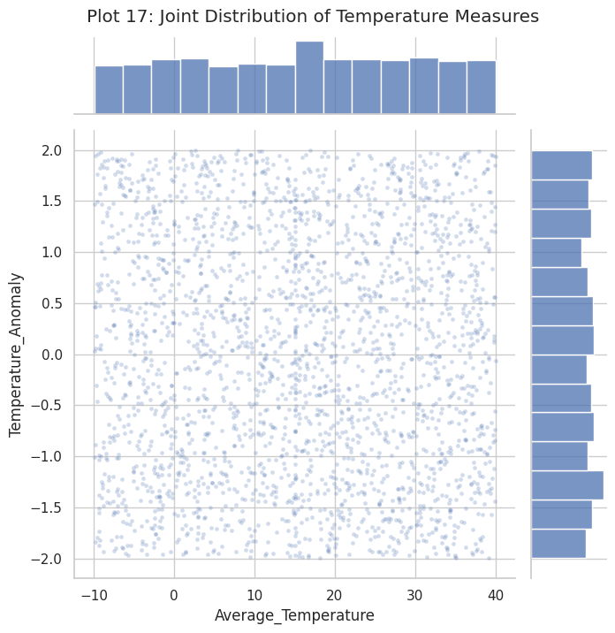  Plot 17. Joint plot: Average_Temperature vs anomaly | Plot 18. Regression plot: Deforestation vs biodiversity
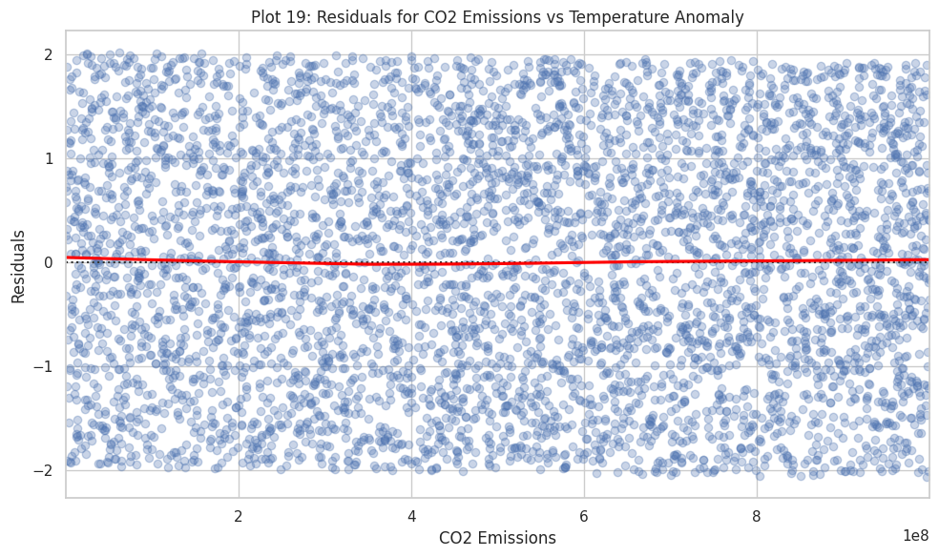  Plot 19. Residual plot: CO2 vs anomaly, LOWESS line | 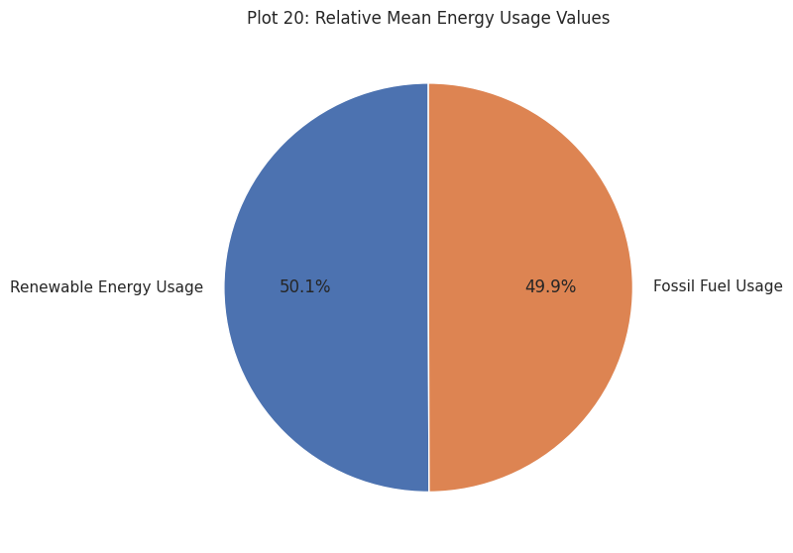  Plot 20. Pie chart: Mean renewable vs fossil fuel usage
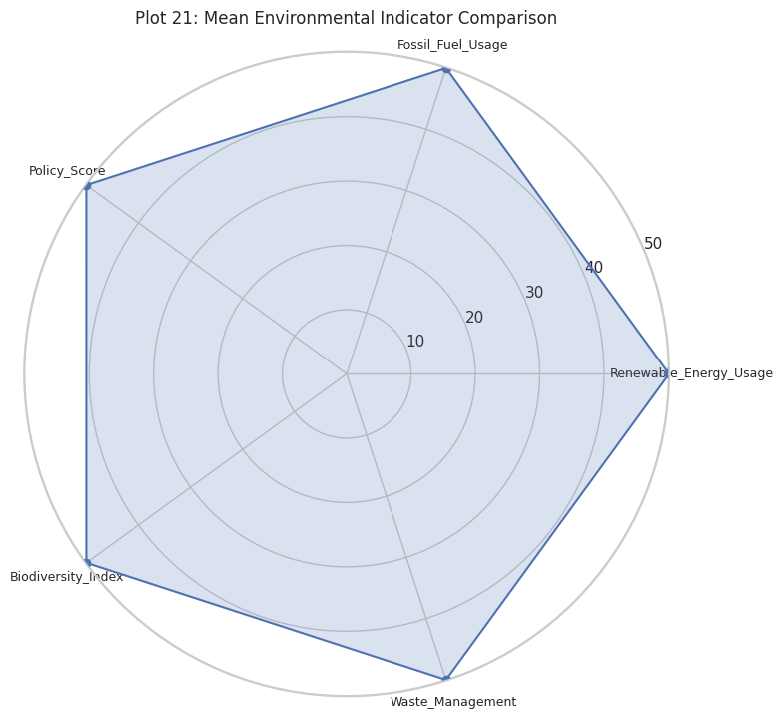  Plot 21. Radar chart: 5 indicator means | 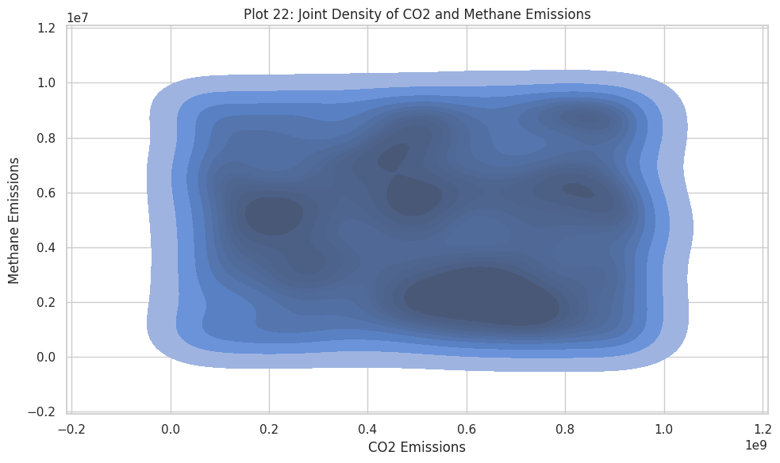  Plot 22. 2-D density: CO2 vs methane emissions
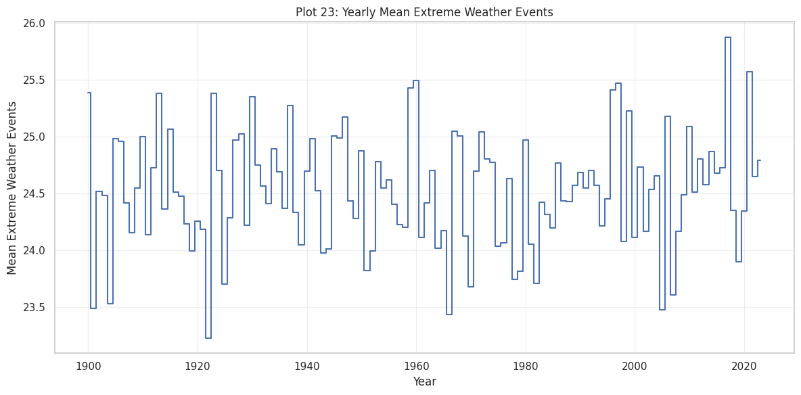  Plot 23. Step chart: Yearly mean extreme weather events | 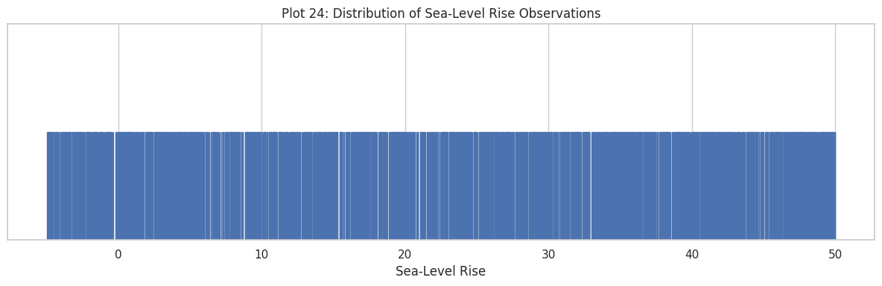  Plot 24. Rug plot: Sea_Level_Rise
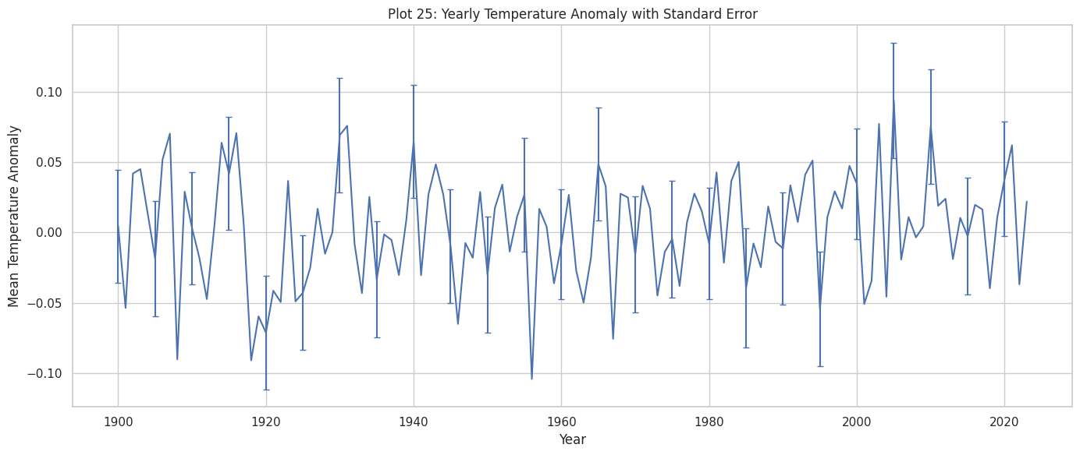  Plot 25. Error-bar line: Yearly mean anomaly ± standard error | 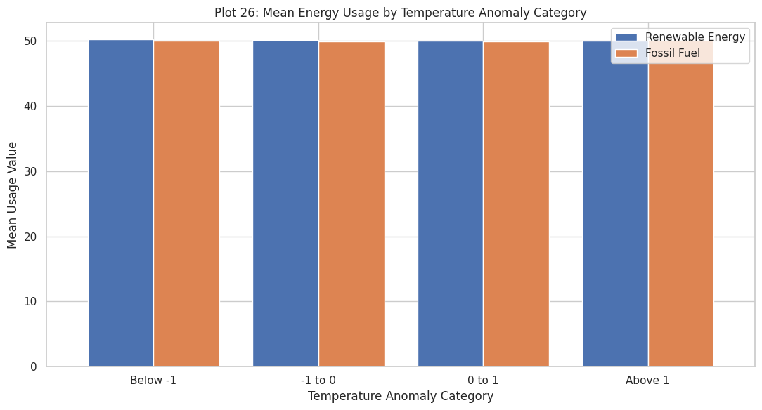  Plot 26. Grouped bar: Energy usage by anomaly category
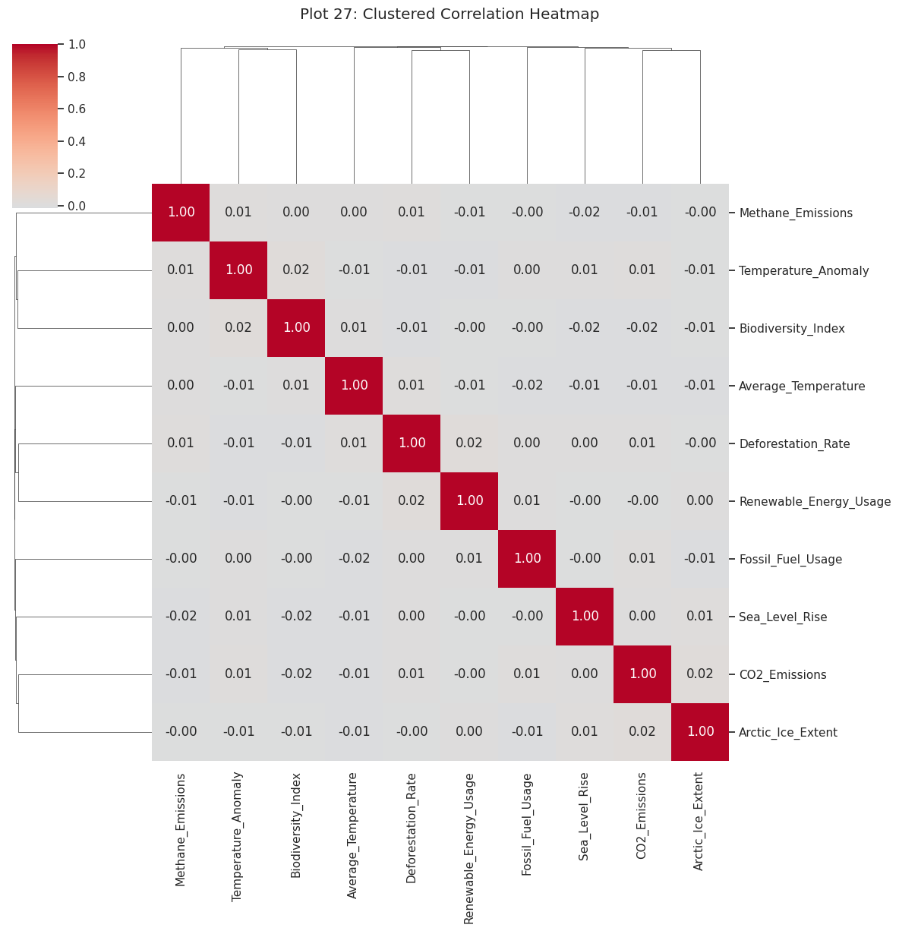  Plot 27. Clustered heatmap: 10-variable correlation | 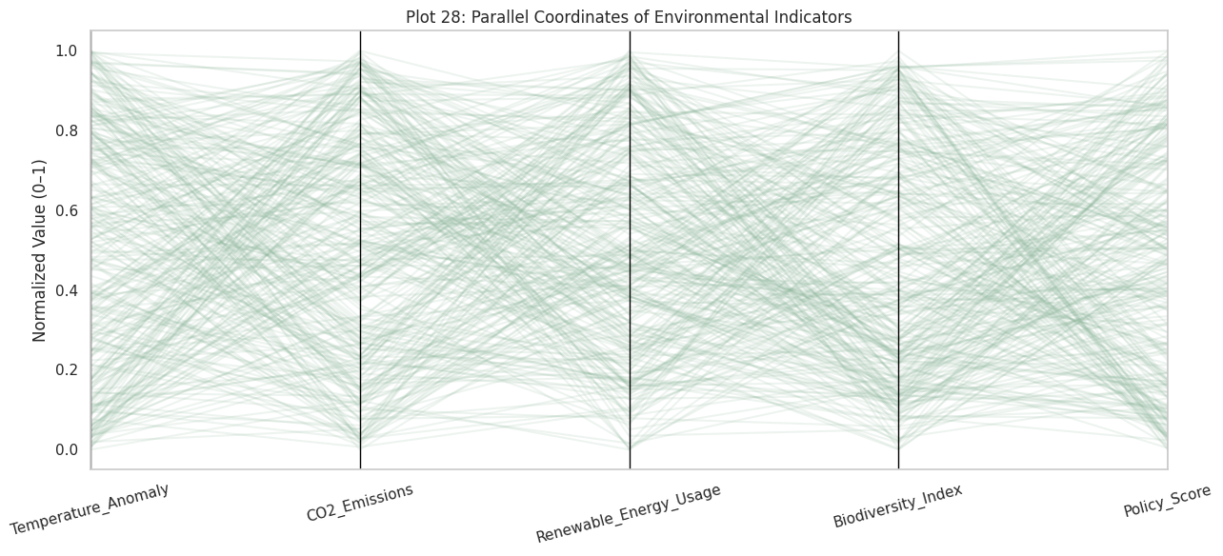  Plot 28. Parallel coordinates: 5 indicators, 300-row sample
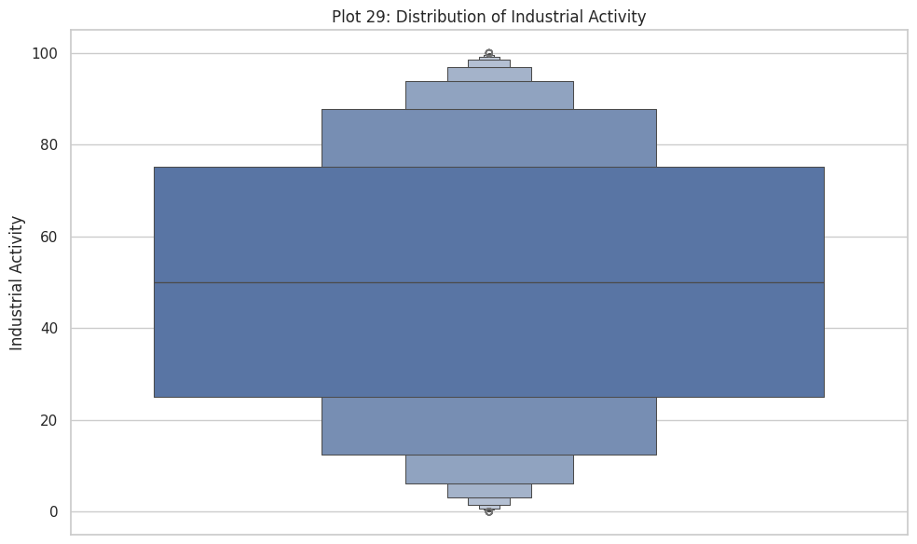  Plot 29. Boxen plot: Industrial_Activity | 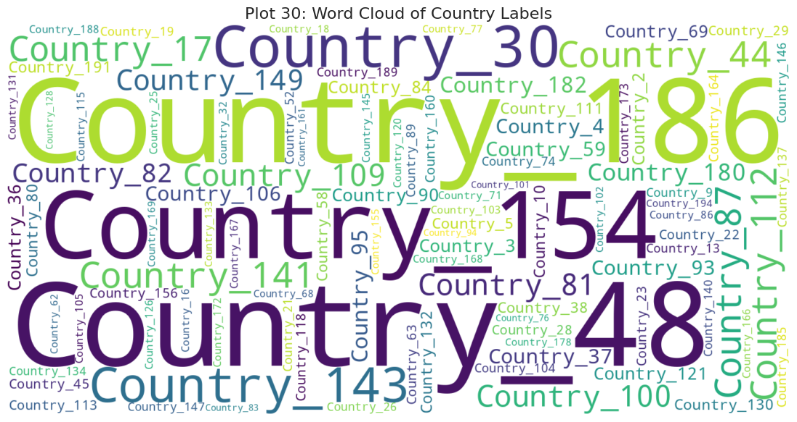  Plot 30. Word cloud: Country labels by row count

